Задание 4

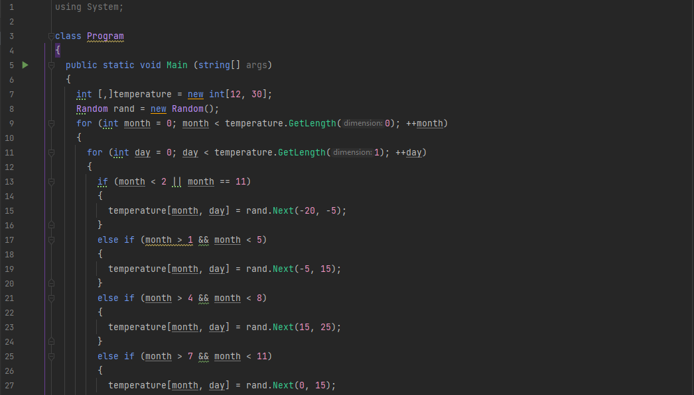

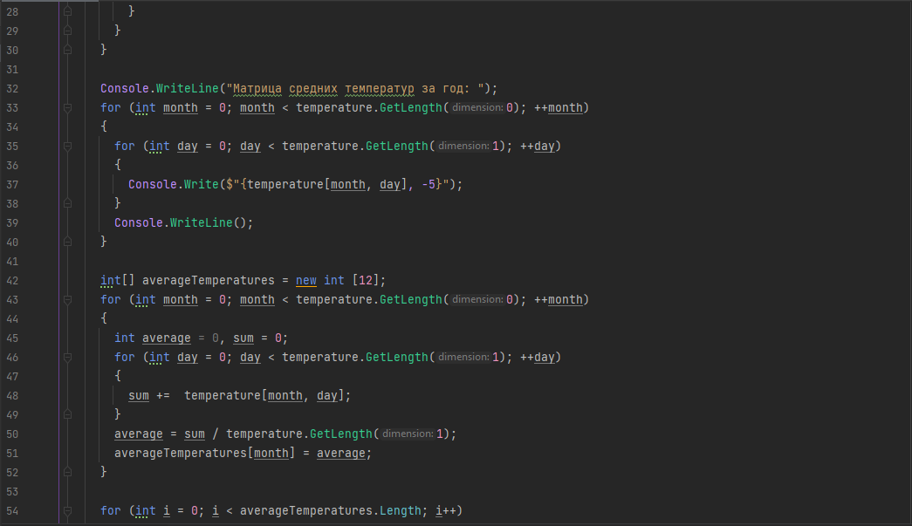

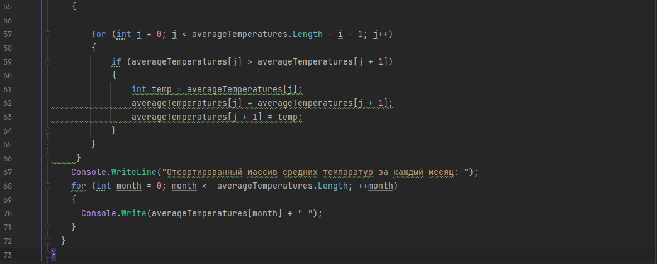

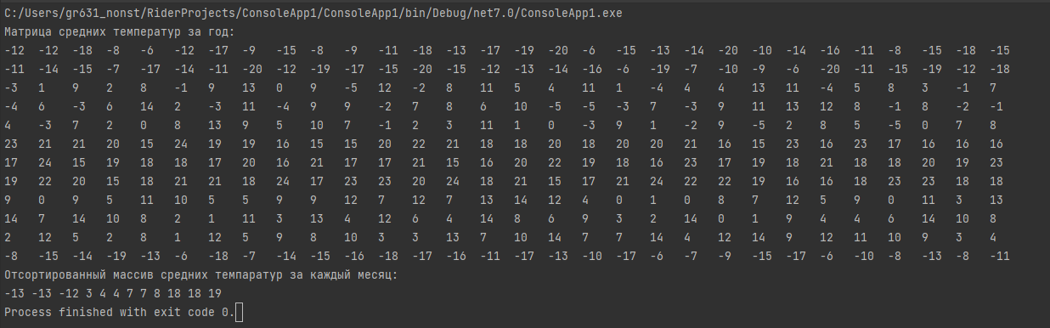

using System;  
  
class Program   
{  
 public static void Main (string[] args)  
 {  
 int [,]temperature = new int[12, 30];  
 Random rand = new Random();  
 for (int month = 0; month < temperature.GetLength(0); ++month)  
 {  
 for (int day = 0; day < temperature.GetLength(1); ++day)  
 {  
 if (month < 2 || month == 11)  
 {  
 temperature[month, day] = rand.Next(-20, -5);  
 }   
 else if (month > 1 && month < 5)  
 {  
 temperature[month, day] = rand.Next(-5, 15);  
 }   
 else if (month > 4 && month < 8)  
 {  
 temperature[month, day] = rand.Next(15, 25);  
 }   
 else if (month > 7 && month < 11)  
 {  
 temperature[month, day] = rand.Next(0, 15);  
 }   
 }  
 }  
  
 Console.WriteLine("Матрица средних температур за год: ");  
 for (int month = 0; month < temperature.GetLength(0); ++month)  
 {  
 for (int day = 0; day < temperature.GetLength(1); ++day)  
 {  
 Console.Write($"{temperature[month, day], -5}");  
 }  
 Console.WriteLine();  
 }  
   
 int[] averageTemperatures = new int [12];  
 for (int month = 0; month < temperature.GetLength(0); ++month)  
 {  
 int average = 0, sum = 0;  
 for (int day = 0; day < temperature.GetLength(1); ++day)  
 {  
 sum += temperature[month, day];  
 }  
 average = sum / temperature.GetLength(1);  
 averageTemperatures[month] = average;  
 }  
  
 for (int i = 0; i < averageTemperatures.Length; i++)  
 {  
   
 for (int j = 0; j < averageTemperatures.Length - i - 1; j++)  
 {  
 if (averageTemperatures[j] > averageTemperatures[j + 1])  
 {  
 int temp = averageTemperatures[j];  
 averageTemperatures[j] = averageTemperatures[j + 1];  
 averageTemperatures[j + 1] = temp;  
 }  
 }  
 }  
 Console.WriteLine("Отсортированный массив средних темпаратур за каждый месяц: ");  
 for (int month = 0; month < averageTemperatures.Length; ++month)  
 {  
 Console.Write(averageTemperatures[month] + " ");  
 }  
 }  
}